Overview

This document describes the creation of a Visual Basic .NET GUI used to demonstrate SPI communication using the PICkit Serial Analyzer DLL.

History

4-23-07 - Original
6-22-07 - Updated to use new Device class

Requirements

- Visual Basic 2005 Express (free download from Microsoft) or Visual Studio 2005
- PICkit Serial Analyzer, firmware version 0201 or later
- Microchip SPI Demo Board
- PICkitS.dll software, version 1.5.0.0 or later

The example GUI in this document will be created using Visual Basic 2005 Express. If you are using Visual Studio, some pictures will vary slightly.

Project creation and dll linking

- Open Visual Basic Express and create a new Windows project (File -> New Project -> Windows Application.
- Name the project SPIExample.
- In the Solution Explorer (upper right corner), select the project SPIExample, then press the “Show All Files” button to reveal all files.

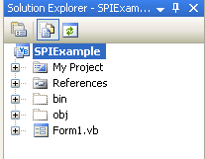

- Right click on References and select ‘Add Reference’ to add the PICkit Serial DLL.
- Select the Browse Tab and navigate to PICkitS.dll and select it. (If you have PICkit Serial Analyzer installed, you can find the dll at C:\Program Files\Microchip\PICkit Serial Analyzer). This allows the GUI to have access to functions embedded in the dll.
- The Solution Explorer should now look like this:
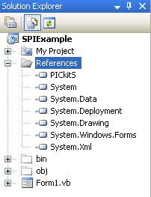

Sending and Receiving Data

- Enlarge the Form a bit and add the following items:

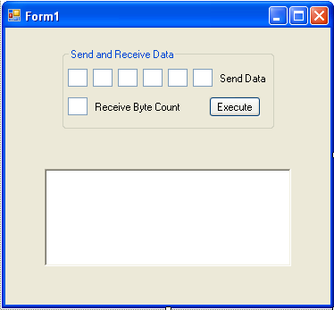

- Seven textboxes, a button, two labels and a groupbox to hold them all
- A richtextbox to display data

- Change the text for the button, groupbox and labels to match the picture above by selecting each and changing the Text in the Properties (lower right corner of IDE)

- Rename the objects per below by selecting each object, then changing the Name in the Properties (lower right corner of IDE):

  - TextBox_Send_Data_0
  - TextBox_Send_Data_1
  - TextBox_Send_Data_2
  - TextBox_Send_Data_3
  - TextBox_Send_Data_4
  - TextBox_Send_Data_5
  - TextBox_Receive_Byte_Count
  - Button_Execute
  - RichTextBox_Display

The groupbox does not need to be renamed.

Now let’s add some initialization code to the form. This will set up the dll properly, configure the PICkit Serial Analyzer for SPI communication, and inform the user of the initialization status.

- Click on the Form in the [Design] tab, and double click the Title bar at the top of the form. This will create a function Form1_Load. Inside this function, type the following:

Private Sub Form1_Load(ByVal sender As System.Object, ByVal e As System.EventArgs) Handles MyBase.Load
If (PICkitS.Device.Initialize_PICkitSerial()) Then
If (PICkitS.SPIM.Configure_PICkitSerial_For_SPIMaster()) Then
RichTextBox_Display.Text += "PICkit Serial correctly configured for SPI Master" & vbCrLf
Else
RichTextBox_Display.Text += "Error configuring PICkit Serial for SPI Master" & vbCrLf
End If
Else
RichTextBox_Display.Text += "Error initializing PICkit Serial" & vbCrLf
End If
End Sub

Note – when you finish typing ‘PICkitS’ and type the ‘.’ A context window should open up and you can select Device by using the up/down arrows to highlight ‘Device’, then pressing the tab key to select it. Do the same with SPI. and Configure_PICkitSerial_For_SPIMaster and add the parens yourself. Pretty cool! The vbCrLf adds a carriage return Line Feed.

- Now we add some cleanup code. Click on the Form in the [Design] tab and in the properties window (lower right corner) select the Events button (lightening bolt) and double click the FormClosed event. Inside that function, type:

PICkitS.Device.Cleanup()

This kills all communication threads and releases dll resources.

- From the menu, press Build -> Build SPIExample to make sure you have no errors at this point. If it does not build correctly, find and fix your errors – they are probably just typos.

- Let’s test your application – all it will do is find and initialize the PICkit Serial Analyzer. Attach the PICkit Serial Analyzer via a USB cable and Press the Start Debugging button

Your application should startup and display the status:

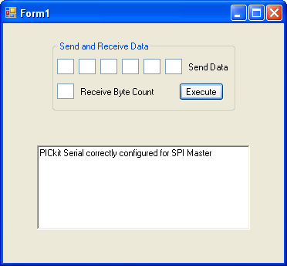

If your application does not find and configure the PICkit Serial Analyzer correctly, check your connections and verify that it is listed under Human Interface Devices in the Device Manager. If you are connecting the PICkit Serial Analyzer through a USB hub, try removing the hub and connecting directly to the PC.

- Close your application.

Now let’s add code to send and receive some data. While SPI commands are very device specific, our code sends generic data, receives data, or both sends and receives data depending on what the user puts in the textboxes. The first command always prepends the assert chip select command while the last command always appends the de-assert chip select command.

- Double click the Execute button and add this code:

Dim SendDataArray(5) As Byte
' data we send stored here
Dim ReceiveDataArray(255) As Byte
' data we receive stored here
Dim SendByteCount As Byte = 0
' how many data bytes in SendDataArray
Dim ReceiveByteCount As Byte = 0
' how many data bytes in RetrieveDataArray
Dim SendTextBoxArray(5) As TextBox
' array to hold send textboxes
Dim index As Integer
' counter
Dim Return_Str As String = ""
' returns string representation of command - we won't use this
Dim DeAssert As Boolean
' whether or not to append chip select de-assert
Dim Assert As Boolean
' whether or not to prepend chip select assert
Dim Display_Str As String = ""
' temporary storage for display
' clear the arrays
Array.Clear(SendDataArray, 0, SendDataArray.Length)
Array.Clear(ReceiveDataArray, 0, ReceiveDataArray.Length)
' popuplate array of textboxes
SendTextBoxArray(0) = TextBox_Send_Data_0
SendTextBoxArray(1) = TextBox_Send_Data_1
SendTextBoxArray(2) = TextBox_Send_Data_2
SendTextBoxArray(3) = TextBox_Send_Data_3
SendTextBoxArray(4) = TextBox_Send_Data_4
SendTextBoxArray(5) = TextBox_Send_Data_5
' loop through textbox array and populate SendDataArray
For index = 0 To SendTextBoxArray.Length - 1
If (SendTextBoxArray(index).Text <> "") Then
' this textbox has data, add to byte array
SendDataArray(index) = Convert.ToByte(SendTextBoxArray(index).Text, 16)
' 16 assumes this is hex data
' increment send byte count
SendByteCount += 1
Else
' no more data, get out of for loop
Exit For
End If
Next
' now see if we are retrieving data
If (TextBox_Receive_Byte_Count.Text <> "") Then
ReceiveByteCount = Convert.ToByte(TextBox_Receive_Byte_Count.Text, 16)
' 16 assumes this is hex data
End If
' we have all our data, now send commands
' if SendByteCount <> 0 then first we use the
If (SendByteCount <> 0) Then
' need to use PICkitS.SPIM.Send_Data
' if we are retrieving data, do no send de-assert command
If (ReceiveByteCount <> 0) Then
DeAssert = False
' we will send the retrieve command also
Else
DeAssert = True
' not retrieving data, so send de-assert command
End If
' first command, so p_assert_cs is true
If (PICkitS.SPIM.Send_Data(SendByteCount, SendDataArray, True, DeAssert, Return_Str)) Then
For index = 0 To SendByteCount - 1
Display_Str += SendTextBoxArray(index).Text & " "
Next index
RichTextBox_Display.Text += "Sent Data: " & Display_Str & vbCrLf
Else
RichTextBox_Display.Text += "Error sending SPI.Send_Data" & vbCrLf
End If
End If
' now see if we need to send receive command
If (ReceiveByteCount <> 0) Then
If (SendByteCount <> 0) Then
Assert = False
' we already asserted, do not assert again
Else
Assert = True
' have not yet asserted, so need to now
End If
Display_Str = ""
' clear Display_Str for this command
' last commmand so p_de_assert_cs is true
If (PICkitS.SPIM.Receive_Data(ReceiveByteCount, ReceiveDataArray, Assert, True, Return_Str)) Then
For index = 0 To ReceiveByteCount - 1
Display_Str += Convert.ToString(ReceiveDataArray(index), 16) & " "
Next index
RichTextBox_Display.Text += "Received Data: " & Display_Str & vbCrLf
Else
RichTextBox_Display.Text += "Error sending SPI.Receive_Data" & vbCrLf
End If
End If

- Let’s write some data to the SPI demo board EE and then read it back out. Build your project, fix any errors, attach the SPI demo board and press the Start Debugging button. Make sure the jumper on the demo board is across JP-1 (the jumper nearest the PICkit Serial connector).

- Enter 06 into the first send data text box. This is the command to enable writes for this device. Now press the Execute button.

- Enter 02 00 22 33 44 55 into the send data textboxes and press the Execute button. We are writing data bytes 22 33 44 55 to the EE starting at address 00. 02 is the write command

- Now enter 03 00 into the first two send data textboxes and clear the remaining textboxes. Enter 04 into the receive byte count textbox and press the Execute button. 03 is the command to read EE, 00 is the starting address, and 04 is the byte count. Your GUI should look like this:

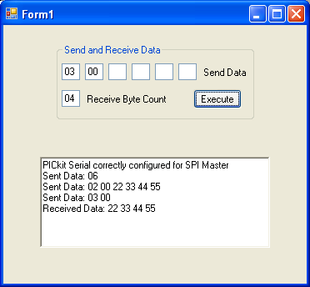

- Close your application.

Bit Rate

Let’s look at how we change the SPI bit rate.

- Add four new objects to the GUI and name them per below (you may have to increase the size of the GUI some):

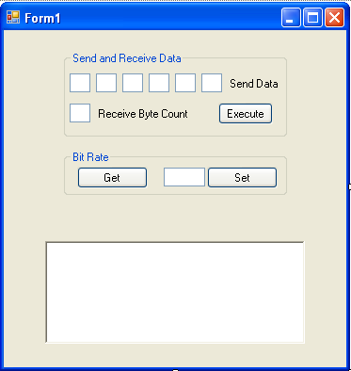

  - Button_Get_Bit_Rate
  - TextBox_Bit_Rate_Set
  - Button_Set_Bit_Rate

- Double click the Get Button and add the following code:

Dim BitRate As Double
BitRate = PICkitS.SPIM.Get_SPI_Bit_Rate()
If (BitRate = 0) Then
RichTextBox_Display.Text += "Error retrieving spi bit rate" & vbCrLf
PICkitS.Device.Reset_Control_Block() ' clear any errors in PKSA
Else
RichTextBox_Display.Text += "Bit rate = " & String.Format("{0:0.00}", BitRate) & " kHz" & vbCrLf
End If

- Double click the Set button and add the following code:

Dim BitRate_Set As Double
BitRate_Set = Convert.ToDouble(TextBox_Bit_Rate_Set.Text)
If (PICkitS.SPIM.Set_SPI_BitRate(BitRate_Set) = True) Then
RichTextBox_Display.Text += "Bit rate set" & vbCrLf
Else
RichTextBox_Display.Text += "Error setting SPI bit rate" & vbCrLf
PICkitS.Device.Reset_Control_Block() ' clear any errors in PKSA
End If

- Build and run your application. Click the Get button to display the SPI bit rate (the initialization routine should have set it to 9.77 kHz).

- Now change the bit rate by entering a different number into the textbox then pressing the Set button. Verify the change by pressing the Get button again. (Note – the bit rate must be in the range of 0.61 <= Bit Rate <= 2500). The value you read back may not match exactly the value you entered due to quantization of the bit rate in the PICkit Serial firmware. PICkitS.SPIM.Set_SPI_BitRate finds the best match to the requested bit rate from the available values.

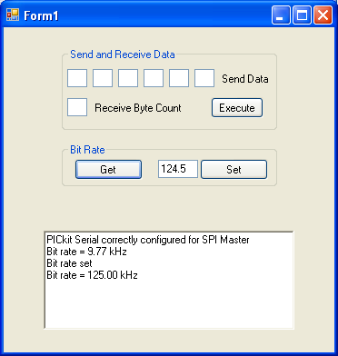
- Close your application.
Voltage Source

You cannot vary the voltage source for SPI devices from the PICkit Serial Analyzer, but you can turn on or off a constant 5V source. Let’s see how.

- Add a checkbox to the GUI and name it per below (you may have to increase the size of the GUI some):

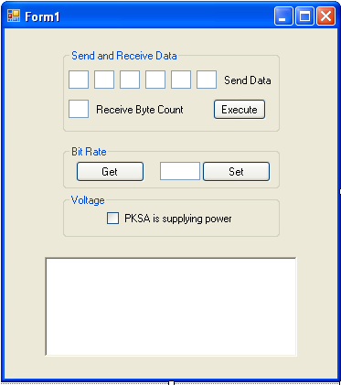

  - CheckBox_Voltage

- Double click the checkbox and add the following code:

If (CheckBox_Voltage.Checked) Then
' tell pksa to power device
If (PICkitS.SPIM.Tell_PKSA_To_Power_My_Device()) Then
RichTextBox_Display.Text += "PKSA is powering my device" & vbCrLf
Else
RichTextBox_Display.Text += "Error telling PKSA to power my device" & vbCrLf
PICkitS.Device.Reset_Control_Block() ' clear any errors in PKSA
End If
Else
' tell pksa not to power device
If (PICkitS.SPIM.Tell_PKSA_To_Use_External_Voltage_Source()) Then
RichTextBox_Display.Text += "PKSA is not powering my device" & vbCrLf
Else
RichTextBox_Display.Text += "Error telling PKSA not to power my device" & vbCrLf
PICkitS.Device.Reset_Control_Block() ' clear any errors in PKSA
End If
End If

- Build and run your application. Connect a voltmeter across pins 2 and 3 and toggle the checkbox on the GUI. The voltage should toggle between 0V and 5V.

- Close your application.

Status

Finally, let’s look at retrieving the SPI status bits from the PICkit Serial Analyzer.

- Add the following checkboxes and button to the GUI and name them per below (you may have to increase the size of the GUI some):

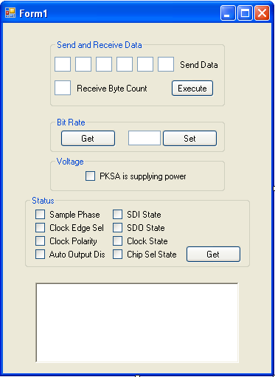

  - CheckBox_Sample_Phase
  - CheckBox_Clock_Edge_Select
  - CheckBox_Clock_Polarity
  - CheckBox_Auto_Output_Disable
  - CheckBox_SDI_State
  - CheckBox_SDO_State
  - CheckBox_Clock_State
  - CheckBox_Chip_Select_State
  - Button_Get_Status

- Double click the button and add the following code:

If (PICkitS.SPIM.Get_SPI_Status(CheckBox_Sample_Phase.Checked, _
CheckBox_Clock_Edge_Select.Checked, _
CheckBox_Clock_Polarity.Checked, _
CheckBox_Auto_Output_Disable.Checked, _
CheckBox_SDI_State.Checked, _
CheckBox_SDO_State.Checked, _
CheckBox_Clock_State.Checked, _
CheckBox_Chip_Select_State.Checked)) Then
RichTextBox_Display.Text += "Retrieved Status" & vbCrLf
Else
RichTextBox_Display.Text += "Error getting PKSA status" & vbCrLf
PICkitS.Device.Reset_Control_Block() ' clear any errors in PKSA
End If

- Build and run your application. Press the Get button to display the eight status bits.

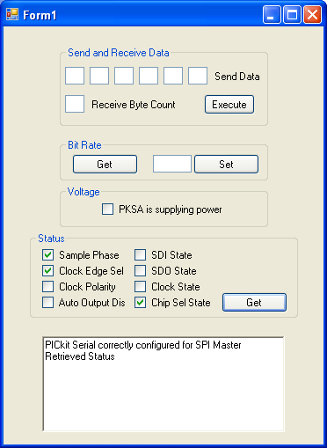

- Close your application.

Other Functions

It is worth mentioning a few other functions not used in the accompanying example project. See PICkitS Function Prototypes.doc for more details.

public static bool Configure_PICkitSerial_For_SPIMaster(
bool p_sample_phase,
bool p_clock_edge_select,
bool p_clock_polarity,
bool p_auto_output_disable
bool p_chip_sel_polarity,
bool p_supply_5V)

This is part of class PICkitS.SPIM and Overrides Configure_PICkitSerial_For_SPIMaster() to include the above options.

public static void Flash_LED1_For_2_Seconds()

Found in PICkitS.Device – can be called anytime to flash LED1 for approximately 2 seconds. Used to verify communication with PICkit Serial Analyzer. Flashing will stop on its own – there is no function call to stop flashing.

public static void Set_Script_Timeout(int p_time)

Found in PICkitS.Device – When sending any script to the PICkit Serial Analyzer, the dll will wait for the script to complete and then verify there were no status errors. The script timeout is the maximum time the dll will wait for the script to finish. The default value is 1000 (one second).

public static bool There_Is_A_Status_Error(ref uint p_error)

This function is in PICkitS.Status and can be used to get detailed error information. You would call this function after an error, but before the

PICkitS.Device.Reset_Control_Block() function call.

Note – whenever you call PICkitS.Device.Reset_Control_Block(), bit rate may get reset to default values. A good practice is to create a setup function in your application that sets all of the parameters you are interested in – then call that function from the Form1_Load routine and everytime you get an error from the PICkit Serial Analyzer.

